Comparative Analysis of AND, OR, and XOR-Based Artificial Neural Networks for Credit Score Classification

Author(s)

[In the submission process (Step 3. Entering the Submission's Metadata), Author(s) must fill out authors’ information that consist of author First, Middle and Last Name (if author only uses one name, fill the first name and last name with the same name), Gender, Initial, Username, Password, Affiliation (University / or Institution), E-mail, Mailing Address (complete address of affiliation), Country and Bio Statement. Do not put this information on the submitted manuscript]]

Abstract – Credit scoring plays a crucial role in assessing an individual's creditworthiness and supporting lending decisions in financial institutions. The increasing complexity of financial data has encouraged the adoption of Artificial Neural Networks (ANN) to improve classification performance. This study aims to compare the performance of ANN architectures based on AND, OR, and XOR logical representations for credit score classification. The Credit Score Classification dataset obtained from Kaggle was used, consisting of 100,000 training records and 50,000 testing records with multiple financial and behavioral attributes. Data preprocessing included data cleaning, missing value imputation, label encoding, and Min-Max normalization. Three ANN architectures were developed to represent AND, OR, and XOR logical behaviors. Model performance was evaluated using accuracy, precision, recall, and F1-score metrics. Experimental results show that the XOR-based ANN achieved the highest performance with an accuracy of 65.53%, precision of 69.95%, recall of 65.53%, and F1-score of 65.82%. The OR-based ANN obtained an accuracy of 64.62%, while the AND-based ANN achieved 53.97%. These findings indicate that nonlinear representations provided by XOR architectures are more effective in capturing complex relationships among credit-related attributes than simpler linear architectures. The study contributes to understanding the influence of logical neural representations on credit score classification and demonstrates the effectiveness of XOR-based neural networks for handling complex financial datasets

Keywords: Artificial Neural Network; Credit Score Classification; AND Logic; OR Logic; XOR Logic.

- INTRODUCTION

Credit scoring is a fundamental process used by financial institutions to assess the creditworthiness of customers and support lending decisions. Accurate credit score classification helps financial organizations minimize default risk, improve decision quality, and maintain financial stability [1], [2]. As the volume and complexity of financial data continue to increase, traditional rule-based and statistical approaches face limitations in capturing nonlinear relationships among customer financial attributes [3]-[6]. Consequently, machine learning and artificial intelligence techniques have become increasingly important in modern credit scoring systems [7], [8]. Recent studies have demonstrated that machine learning-based credit scoring models can significantly improve predictive performance and decision-making effectiveness compared with conventional approaches [8].

Artificial Neural Networks (ANNs) have emerged as one of the most widely adopted machine learning techniques for credit risk assessment due to their capability to learn complex and nonlinear relationships from high-dimensional data [9]. Previous studies have reported that ANN-based approaches achieve competitive performance in credit scoring, credit approval prediction, and credit risk classification tasks [10], [11]. Neural networks are particularly effective in modeling interactions among financial variables that are difficult to represent using traditional linear methods. Furthermore, recent surveys on machine learning-powered credit scoring indicate that neural network architectures remain among the most promising approaches for financial classification problems because of their adaptability and predictive capability [12], [13].

Various machine learning and deep learning algorithms have been applied to credit scoring problems, including Logistic Regression, Decision Trees, Support Vector Machines, Random Forests, Gradient Boosting, and Deep Neural Networks [14]. Comparative studies have shown that nonlinear models generally outperform linear models when handling complex financial datasets due to their ability to capture hidden patterns and multidimensional feature interactions [15]. Recent research has also emphasized that credit scoring datasets often contain nonlinear relationships among demographic, behavioral, and financial attributes, making neural-network-based solutions particularly attractive for classification tasks .

One of the fundamental concepts underlying neural network development is logical representation. Logical operators such as AND, OR, and XOR have historically played an important role in the evolution of neural network architectures [14][16], [17], [18]. AND and OR are linearly separable problems that can be solved using single-layer perceptrons, whereas XOR represents a nonlinear problem that requires hidden-layer representations. The XOR problem has long been recognized as a milestone in demonstrating the necessity of multilayer neural networks for solving complex classification tasks. Although numerous studies have investigated ANN applications in credit scoring, limited research has explored the impact of different logical neural representations, particularly AND-, OR-, and XOR-based architectures, on credit score classification performance [16].

Based on the identified research gap, this study aims to compare the performance of Artificial Neural Networks inspired by AND, OR, and XOR logical representations for credit score classification [19]. Using the Credit Score Classification dataset obtained from Kaggle, three neural architectures were developed and evaluated using accuracy, precision, recall, and F1-score metrics. The findings are expected to provide a deeper understanding of how logical neural representations influence classification performance and to demonstrate the effectiveness of nonlinear architectures for handling complex financial datasets.

- RESEARCH METHODS

- Dataset

This study utilized the Credit Score Classification dataset obtained from Kaggle. The dataset contains customer demographic, financial, and behavioral information that can be used to classify credit scores into three categories: Good, Poor, and Standard. The original training dataset consists of 100,000 records with 28 attributes, while the testing dataset contains 50,000 records. After preprocessing, 23 predictive features were retained for model development.

The target variable of this study is Credit_Score, which represents the creditworthiness category of each customer. The dataset includes various financial indicators such as annual income, number of bank accounts, number of credit cards, outstanding debt, credit utilization ratio, payment behavior, and monthly balance.

- Data Preprocessing

Data preprocessing was conducted to improve data quality and ensure that all variables could be effectively processed by the Artificial Neural Network (ANN) models. The preprocessing procedure consisted of several stages. First, irrelevant attributes, including ID, Customer_ID, Name, and SSN, were removed because they did not contribute to the prediction process. Next, data cleaning was performed to eliminate invalid characters and correct inconsistent values found in numerical attributes. Unreasonable age values, specifically those below 18 years and above 100 years, were identified and treated as missing values to maintain data reliability. Missing values were then handled through imputation, where the median was applied to numerical attributes and the mode was used for categorical attributes. Subsequently, label encoding was performed on categorical variables such as Occupation, Credit_Mix, Payment_of_Min_Amount, and Payment_Behaviour to convert them into numerical representations suitable for model training. The target variable, Credit_Score, was also transformed using label encoding. Finally, feature normalization was applied using the Min-Max normalization technique, which scaled all numerical attributes to a uniform range between 0 and 1, ensuring consistent input distributions and improving the learning performance of the ANN models.

- Data Splitting

The normalized dataset was divided into training and testing sets using a stratified holdout approach. A total of 80% of the data was allocated for training, while the remaining 20% was used for testing. Stratified sampling was applied to preserve the original class distribution of the target variable.

- ANN Architectures

This study compared three Artificial Neural Network architectures inspired by AND, OR, and XOR logical representations.

- AND-Based Neural Network
The AND-based model represents the simplest logical architecture. It consists of a single hidden neuron followed by an output layer containing three neurons corresponding to the three credit score classes. The architecture is designed to emulate the restrictive behavior of AND logic.

- OR-Based Neural Network
The OR-based model provides a more flexible logical representation than the AND model. The architecture contains eight hidden neurons followed by an output layer with three neurons.

- XOR-Based Neural Network
The XOR-based model represents a nonlinear architecture capable of learning complex relationships among financial attributes. The model consists of three hidden layers with 128, 64, and 32 neurons respectively.

All hidden layers utilized the Rectified Linear Unit (ReLU) activation function, while the output layer employed the Softmax activation function to perform multiclass classification.

- Model Training

The models were trained using the Adam optimization algorithm and Sparse Categorical Crossentropy loss function. To address class imbalance, class weighting was applied during training. Furthermore, Early Stopping was employed to prevent overfitting by monitoring validation loss and restoring the best model weights.
Table 1 Training Parameters

Parameter | Value
Optimizer | Adam
Loss Function | Sparse Categorical Crossentropy
Batch Size | 64
Maximum Epochs | 100
Validation Split | 20%
Early Stopping Patience | 10
Activation Function | ReLU
Output Activation | Softmax

- Performance Evaluation

The performance of each model was evaluated using Accuracy, Precision, Recall, and F1-Score metrics. In addition, a confusion matrix was generated to analyze classification performance for each credit score category.

$Accuracy= \frac{TP+TN}{TP+FP+FN+TN}$ (1)

$Precision= \frac{TP}{TP+FP}$ (2)

$Recall= \frac{TP}{TP+FN}$ (3)

$F1-Score= 2 x \frac{P x R}{P+R}$ (4)

where TP represents True Positive, TN denotes True Negative, FP indicates False Positive, and FN refers to False Negative.
Precision, Recall, and F1-Score were also computed to provide a comprehensive evaluation of model performance in multiclass classification.

- RESULTS AND DISCUSSION

- Result

Three Artificial Neural Network architectures inspired by AND, OR, and XOR logical representations were developed and evaluated using the Credit Score Classification dataset. All models were trained using identical preprocessing procedures, training parameters, and evaluation metrics to ensure a fair comparison.

Table 2 Performance Comparison of AND, OR, and XOR Neural Networks

Model | Accuracy (%) | Precision (%) | Recall (%) | F1-Score (%)
AND | 53.97 | 60.36 | 53.97 | 53.63
OR | 64.62 | 69.44 | 64.62 | 64.99
XOR | 65.53 | 69.95 | 65.53 | 65.82

The results indicate that the XOR-based Artificial Neural Network achieved the highest performance among all evaluated architectures. The XOR model obtained an accuracy of 65.53%, followed by the OR model with 64.62%, while the AND model produced the lowest accuracy of 53.97%.

The performance improvement from AND to OR reached approximately 10.65 percentage points, while the XOR architecture further improved classification performance by achieving the highest overall accuracy, precision, recall, and F1-score values.

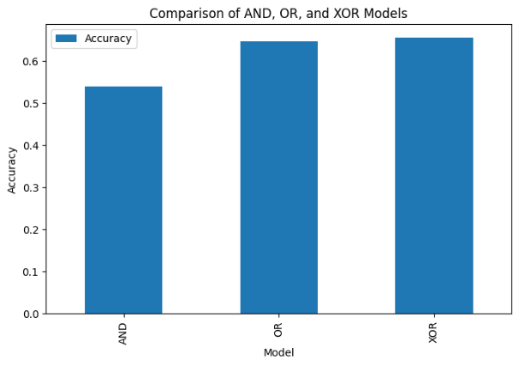
Figure 1. Accuracy Comparison of AND, OR, and XOR Neural Networks

Figure 1 illustrates the classification accuracy achieved by the three evaluated neural network architectures. The XOR-based neural network obtained the highest classification accuracy of 65.53%, followed by the OR-based model with 64.62%, while the AND-based model achieved 53.97%. The results indicate a consistent improvement in classification performance as the representational complexity of the neural architecture increases. The findings suggest that nonlinear neural representations are more effective in modeling the complex relationships present in credit scoring datasets.

Further analysis using Precision, Recall, and F1-score revealed that the model achieved strong performance in detecting customers with clear credit profiles, whereas customers belonging to the Standard category often exhibited intermediate financial characteristics that increased classification difficulty.

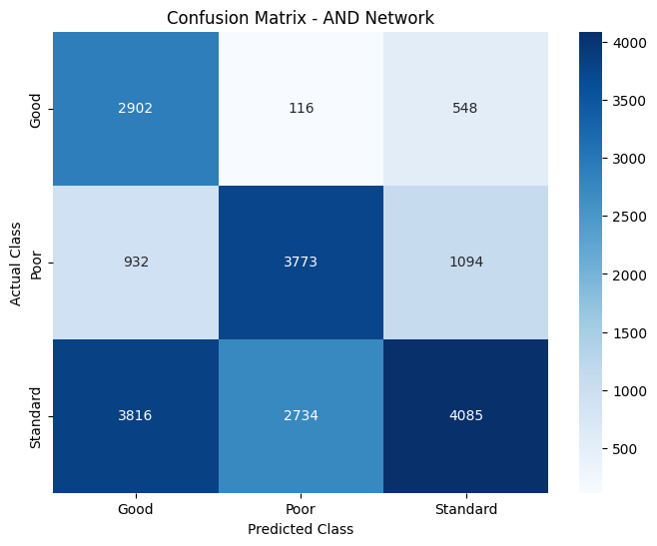
Figure 2. Confusion Matrix of AND-Based Neural Network

The confusion matrix of the AND-based neural network is presented in Figure 2. The model correctly classified 2,902 instances of the Good class, 3,773 instances of the Poor class, and 4,085 instances of the Standard class. However, a considerable number of Standard-class records were misclassified as Good (3,816 instances) and Poor (2,734 instances). Similarly, 1,094 Poor-class instances were incorrectly predicted as Standard.

These results indicate that the AND architecture struggled to distinguish between the three credit score categories. The limited representational capacity of the AND-based neural network, which utilizes a single hidden neuron, restricted its ability to capture complex relationships among financial variables. Consequently, the model produced the lowest overall classification performance among the evaluated architectures. The findings suggest that simple linear representations are insufficient for modeling the nonlinear characteristics inherent in credit score classification problems.

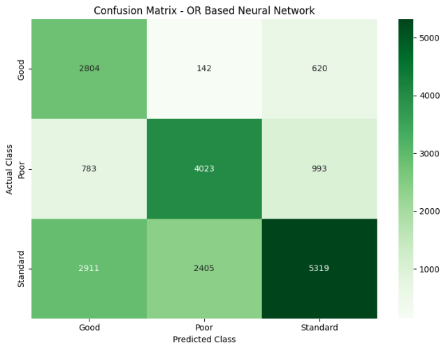
Figure 3. Confusion Matrix of OR-Based Neural Network

Figure 3 illustrates the confusion matrix obtained from the OR-based neural network. The model successfully classified 2,804 Good-class instances, 4,023 Poor-class instances, and 5,319 Standard-class instances. Compared with the AND architecture, the OR model demonstrated a noticeable improvement in identifying all three classes. The number of correctly classified Standard instances increased significantly, while the misclassification rate decreased.

Nevertheless, the model still encountered difficulties in distinguishing Standard-class customers from the other categories. A total of 2,911 Standard instances were incorrectly classified as Good, while 2,405 instances were classified as Poor. In addition, 993 Poor-class records were predicted as Standard. These findings indicate that although the OR architecture provides greater flexibility than the AND model, its relatively shallow structure still limits its capability to learn highly complex nonlinear relationships among financial attributes.

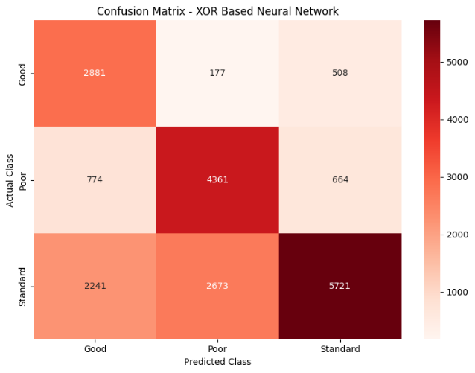
Figure 4. Confusion Matrix of XOR-Based Neural Network

Figure 4 presents the confusion matrix of the XOR-based neural network, which achieved the highest classification performance among all evaluated models. The model correctly classified 2,881 Good-class instances, 4,361 Poor-class instances, and 5,721 Standard-class instances. Compared with the AND and OR architectures, the XOR model produced the largest number of correct classifications across all categories.

The confusion matrix reveals that the XOR architecture was particularly effective in identifying Poor and Standard credit score classes. Although some Standard instances were still misclassified as Good (2,241 instances) and Poor (2,673 instances), the overall classification performance was superior to that of the AND and OR models. The improved results can be attributed to the multilayer structure of the XOR-based neural network, which enables the model to learn nonlinear decision boundaries and capture complex interactions among financial indicators.

These findings support the theoretical assumption that credit score classification is inherently a nonlinear problem. The superior performance of the XOR architecture demonstrates that deeper neural representations are more effective in modeling multidimensional financial data and improving classification accuracy.

A comparison of Figures 2–4 demonstrates a consistent improvement in classification performance from the AND architecture to the OR architecture and finally to the XOR architecture. The AND model exhibited the highest level of misclassification, particularly for the Standard class. The OR model reduced classification errors through a more flexible hidden-layer representation, while the XOR model achieved the best overall performance by utilizing multiple hidden layers capable of learning complex nonlinear patterns. These results confirm that increasing neural network complexity improves the model's ability to classify customer credit scores accurately.

- Discussion

The experimental findings demonstrate that logical representation significantly influences the classification capability of Artificial Neural Networks. The AND architecture produced the lowest performance because its structure contains only a single hidden neuron, limiting its ability to learn complex patterns from financial data. Consequently, the model behaved similarly to a linear classifier and struggled to represent the multidimensional relationships among customer financial attributes.

The OR architecture achieved substantially better performance than the AND architecture. The addition of multiple hidden neurons enabled the network to learn more flexible decision boundaries and capture a greater number of feature interactions. This improvement confirms that increasing model capacity enhances classification performance in credit scoring tasks.

Among the evaluated architectures, the XOR-based neural network achieved the best overall performance. The XOR architecture employed multiple hidden layers, allowing the network to learn nonlinear relationships among demographic, behavioral, and financial attributes. This finding is consistent with neural network theory, which states that XOR-type representations require hidden-layer processing to model nonlinear decision boundaries effectively.

The superiority of the XOR model suggests that credit score classification is inherently a nonlinear problem. Financial indicators such as annual income, outstanding debt, payment behavior, credit utilization ratio, and credit history do not influence creditworthiness independently. Instead, these variables interact in complex ways that cannot be adequately represented using simple linear decision functions. The multilayer structure of the XOR network enables the model to capture such interactions more effectively than AND and OR architectures.

These findings are also consistent with previous studies that reported improved classification performance when deeper neural network architectures were applied to financial prediction and credit risk assessment problems. The results indicate that nonlinear neural representations provide a more suitable framework for modeling real-world financial datasets characterized by complex and multidimensional relationships.

Furthermore, the relatively small performance difference between OR and XOR suggests that even simple hidden-layer expansions can significantly improve classification performance. However, the XOR architecture still achieved the highest evaluation metrics, demonstrating the importance of nonlinear feature learning in credit score classification.

Overall, the experimental results support the research hypothesis that XOR-based Artificial Neural Networks outperform AND- and OR-based architectures for credit score classification. The findings confirm that increasing representational complexity through nonlinear neural structures leads to improved predictive performance when handling complex financial datasets.

- CONCLUSION

This study compared the performance of Artificial Neural Networks inspired by AND, OR, and XOR logical representations for credit score classification using the Credit Score Classification dataset. Data preprocessing involved data cleaning, missing value handling, categorical encoding, and Min-Max normalization prior to model training.

Experimental results demonstrated that the XOR-based neural network achieved the best classification performance with an accuracy of 65.53%, precision of 69.95%, recall of 65.53%, and F1-score of 65.82%. The OR-based architecture achieved an accuracy of 64.62%, while the AND-based architecture produced the lowest performance at 53.97%.

The findings indicate that nonlinear neural architectures are more effective in modeling the complex interactions among financial attributes than simpler linear logical representations. The superior performance of the XOR architecture confirms that credit score classification is inherently a nonlinear problem that benefits from deeper neural network structures capable of learning complex decision boundaries.

Future research may investigate more advanced neural architectures, such as Deep Neural Networks, Long Short-Term Memory (LSTM), Gated Recurrent Units (GRU), or Transformer-based models, as well as feature selection and optimization techniques to further improve credit score classification performance.

REFERENCES

[1] Y. Peng, Exploratory Data Analysis and Credit Score Classification for Credit Scoring Based on Improved Artificial Neural Network Models with Channel Attention Mechanisms, vol. 1, no. 1. Association for Computing Machinery, 2024. doi: 10.1145/3677892.3677908.
[2] M. El Khair Ghoujdam, R. Chaabita, O. Elkhalfi, K. Zehraoui, H. Elalaoui, and S. Idamia, “Consumer credit risk analysis through artificial intelligence: a comparative study between the classical approach of logistic regression and advanced machine learning techniques,” Cogent Econ. Financ., vol. 12, no. 1, p., 2024, doi: 10.1080/23322039.2024.2414926.
[3] J. Duan, “Financial system modeling using deep neural networks (DNNs) for effective risk assessment and prediction,” J. Franklin Inst., vol. 356, no. 8, pp. 4716–4731, May 2019, doi: 10.1016/j.jfranklin.2019.01.046.
[4] Nagajayant Nagamani, “Machine Learning Approaches for Credit Risk Evaluation in Digital Lending Platforms,” J. Electr. Syst., vol. 17, no. 4, pp. 177–182, 2024, doi: 10.52783/jes.9334.
[5] Wilhelmina Afua Addy, Adeola Olusola Ajayi-Nifise, Binaebi Gloria Bello, Sunday Tubokirifuruar Tula, Olubusola Odeyemi, and Titilola Falaiye, “AI in credit scoring: A comprehensive review of models and predictive analytics,” Glob. J. Eng. Technol. Adv., vol. 18, no. 2, pp. 118–129, 2024, doi: 10.30574/gjeta.2024.18.2.0029.
[6] H. Ayari, P. R. Guetari, and P. N. Kraïem, “Machine learning powered financial credit scoring: a systematic literature review,” Artif. Intell. Rev., vol. 59, no. 1, 2026, doi: 10.1007/s10462-025-11416-2.
[7] M. Aslesha, “Artificial Intelligence in Credit Scoring: Enhancing Financial Inclusion & Opportunities,” Int. Res. J. Educ. Technol., vol. 8, no. April, pp. 2400–2407, 2025, doi: 10.5281/zenodo.15256246.
[8] V. Chang, S. Sivakulasingam, H. Wang, S. T. Wong, M. A. Ganatra, and J. Luo, “Credit Risk Prediction Using Machine Learning and Deep Learning: A Study on Credit Card Customers,” Risks, vol. 12, no. 11, 2024, doi: 10.3390/risks12110174.
[9] Jason Brownlee, “Deep Learning for Time Series Forecasting: Predict the Future with MLPs ... - Jason Brownlee - Google Books,” 2018, [Online]. Available: https://books.google.com.ng/books/about/Deep_Learning_for_Time_Series_Forecastin.html?id=o5qnDwAAQBAJ&redir_esc=y
[10] Mohammed Chachan Younis and Raya Akram Hamdy, “Performance Evaluation of Artificial Neural Network Methods Based on Block Machine Learning Classification,” AL-Rafidain J. Comput. Sci. Math., vol. 17, no. 2, pp. 111–123, 2023, doi: 10.33899/csmj.2023.142250.1079.
[11] S. Haykin, Neural Newtorks and Learning Machines Third edition. 2009.
[12] T. D. Adugna, A. Ramu, and A. Haldorai, A Review of Pattern Recognition and Machine Learning, vol. 4, no. 1. 2024. doi: 10.53759/7669/jmc202404020.
[13] J. Heaton, “Ian Goodfellow, Yoshua Bengio, and Aaron Courville: Deep learning,” Genet. Program. Evolvable Mach., vol. 19, no. 1–2, pp. 305–307, 2018, doi: 10.1007/s10710-017-9314-z.
[14] R. Rojas, Neural Networks. Berlin, Heidelberg: Springer Berlin Heidelberg, 1996. doi: 10.1007/978-3-642-61068-4.
[15] F. Rosenblatt, “The perceptron: A probabilistic model for information storage and organization in the brain,” Psychol. Rev., vol. 65, no. 6, pp. 386–408, 1958, doi: 10.1037/h0042519.
[16] G. Zakariya, A. Moldagulova, and N. Ali, “An Explainable Hybrid AI Framework for Real-Time Point-of-Sale Credit Scoring,” AI, vol. 7, no. 6, p. 211, Jun. 2026, doi: 10.3390/ai7060211.
[17] X. Shi, D. Tang, and Y. Yu, “Credit Scoring Prediction Using Deep Learning Models in the Financial Sector,” IEEE Access, vol. 13, pp. 130731–130746, 2025, doi: 10.1109/ACCESS.2025.3591005.
[18] D. U. Chacon, S. Lee, and J. Park, “An explainable machine learning model for consumer credit scoring in Mexico,” Emerg. Mark. Rev., vol. 71, p. 101424, Mar. 2026, doi: 10.1016/j.ememar.2025.101424.
[19] M. Tavakoli, R. Chandra, F. Tian, and C. Bravo, “Multi-modal deep learning for credit rating prediction using text and numerical data streams,” Appl. Soft Comput., vol. 171, p. 112771, Mar. 2025, doi: 10.1016/j.asoc.2025.112771.

